**Implement Browser command and navigation Commands.**

1. Invoke any Browser

Open any URL of your own choice:

Get Page Title name and Title length

Print Page Title and Title length on the Eclipse Console

Get page Source and Page Source length

Print page Length on Eclipse Console.

Close the Browser

Code:

|  |
| --- |
| import org.openqa.selenium.WebDriver;  import org.openqa.selenium.chrome.ChromeDriver;  public class P3 {  public static void main(String[] args) {  WebDriver driver = null;  driver = new ChromeDriver();  try {  String url = "https://siescoms.edu.in/";  driver.get(url);    String pagetitle = driver.getTitle();  int titlelength = pagetitle.length();  System.out.println("Page Title: " + pagetitle);  System.out.println("Page Length: " + titlelength);      String pagesrc = driver.getPageSource();  int srclen = pagesrc.length();  System.out.println("Page Source Length: " + srclen);      }  finally {  driver.quit();  }    }  } |

Output:

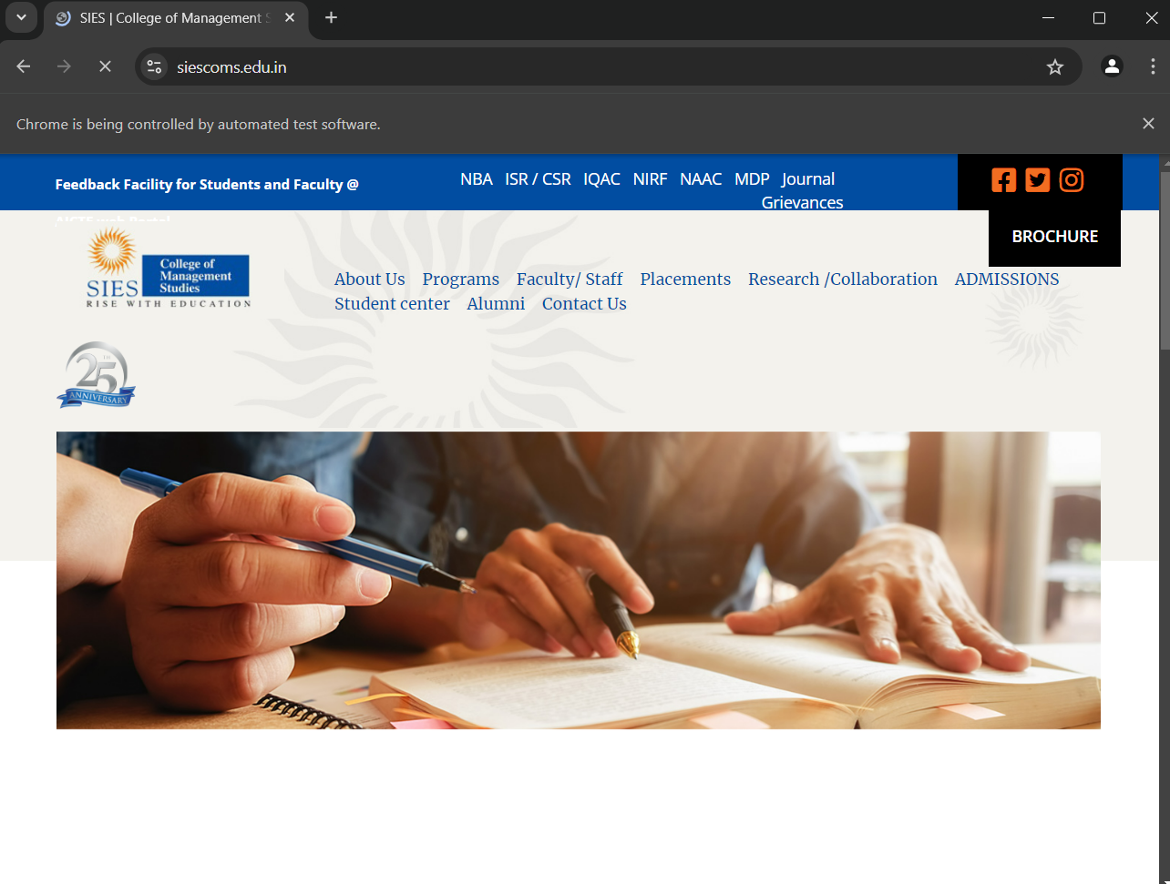

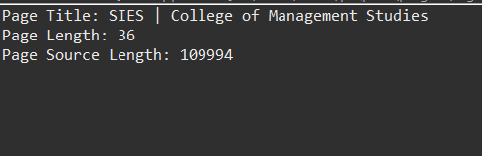

2. Navigation Commands

Invoke any Browser

Navigate to URL of your own choice

Navigate to any other website you own choice.

Come back to the Home page using the back command

Again go back to the website using forward command

Refresh the Browser using Refresh command

Close the Browser.

Code:

|  |
| --- |
| import org.openqa.selenium.WebDriver;  import org.openqa.selenium.chrome.ChromeDriver;  public class P4 {  public static void main(String[] args) throws InterruptedException {    WebDriver driver = null;  driver = new ChromeDriver();    try {  String url = "https://siescoms.edu.in/";  driver.get(url);    Thread.*sleep*(2000);    String url1 = "https://www.google.com";  driver.navigate().to(url1);    Thread.*sleep*(3000);    driver.navigate().back();  Thread.*sleep*(3000);    driver.navigate().forward();  Thread.*sleep*(3000);    driver.navigate().refresh();  Thread.*sleep*(3000);    }  catch(InterruptedException e) {  e.printStackTrace();  }  finally {  driver.quit();    }  }  } |

Output:

Navigate to SIESCOMS website

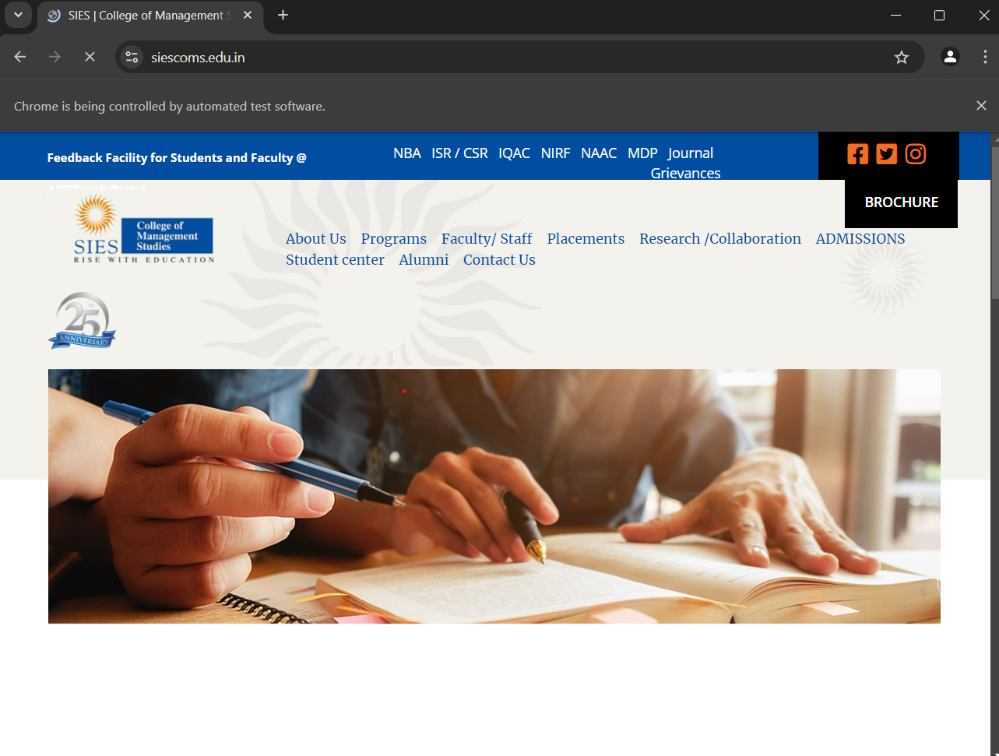

Navigate to Google.com

Navigate back to SIESCOMS website

Navigate forward to Google.com

Refresh the Page and close the browser.

